**Objectives**

1. Use Packet Tracer and familiarize yourself with the user interface.
2. Drag and drop devices and make connections.
3. Use the GUI configuration screens and simulation options.
4. Save the file and re-load it.

NOTE: Refer to the file -01b Using Cisco Packet Tracer.PPT and/or take the free NetAcademy course for more help and information.

**Part A - Create the topology**

* Launch Packet Tracer on your workstation.
* Select OPTIONS/PREFERENCES/MISCELLANEOUS and ensure BUFFER FILTERED EVENTS ONLY is selected.
* Open a textbox (type N and click, or click the  icon, and enter:
  1. “Lab 01”
  2. Your last name followed by your class id (ex: “Tokash-162”)
* Create the following topology by dragging and dropping the items from the device toolbars. (Remember that the toolbar has device groups on the left, and individual devices on the fight.)  
    
  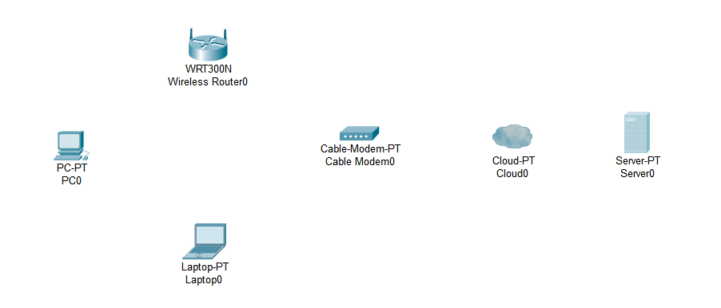  
  To place a device onto the workspace, first choose a device type from the Device-Type Selection box. Then, click on the desired device model from the Device-Specific Selection box. Finally, click on a location in the workspace to put your device in that location. If you want to cancel your selection, click the Cancel icon for that device. Alternatively, you can click and drag a device from the Device-Specific Selection box onto the workspace.  
    
  Note: the cable modem is the Network Devices/WAN group. The Server is in the End Devices group.
* Select OPTIONS/PREFERENCES and de-select SHOW DEVICE MODEL LABELS.
* Change the display names of the network devices to match the below topology diagram:  
    
  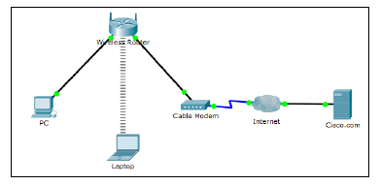  
    
  Click on the device name to open an edit box. Or click on the device icon, then click the **Config** tab, and edit the name in the **Display Name** box as show.
* Using the device selection box, add the physical cabling between devices on the workspace as shown in the topology diagram. *Rather than use the AUTO-SELECT connection, scan over the different connectors to find the correct one.*   
    
  The PC will need a copper straight-through cable to connect to the Wireless Router. Select the copper straight-through cable in the Device-Selection box and attach it to the FastEthernet0 interface of the PC and the Ethernet 1 interface of the Wireless Router.  
    
  The Wireless Router will need a copper straight-through cable to connect to the Cable Modem. Select the copper straight-through cable in the Device-Selection box and attach it to **the Internet interface** of the Wireless Router and the Port 1 interface of the Cable Modem.  
    
  The Cable Modem will need a coaxial cable to connect to the Internet cloud. Select the coaxial cable in the Device-Selection box and attach it to the Port 0 interface of the Cable Modem and the coaxial interface of the Internet cloud.  
    
  The Internet cloud will need copper straight-through cable to connect to the Cisco.com server. Select the copper straight-through cable in the Device-Selection box and attach it to the Ethernet interface of the Internet cloud and the FastEthernet0 interface of the Cisco.com server.
* At this point all cable connections should be operational (green triangle).

**Part B - Configure the Wireless Router**

* Click on the Wireless Router icon on the Packet Tracer Logical workspace to open the device configuration window.
* In the Wireless Router configuration window click on the GUI tab to view configuration options for the Wireless Router.
* Next, click on the Wireless tab in the GUI to view the wireless settings. The only setting that needs to be changed from the defaults is the Network Name (SSID). Here, type the name “HomeNetwork” as shown in the figure. Then click on SAVE SETTINGS!   
     
   
* To configure the Internet connection on the Wireless Router click on the Setup tab in the Wireless Router GUI.
* In the DHCP Server settings verify that the Enabled button is selected and configure the static IP address of the DNS server as 208.67.220.220 as shown in the figure. (Do you recall what DHCP is used for?) Then click SAVE SETTINGS!



**Part C - Configure the Laptop**

* Click on the Laptop icon on the Packet Tracer Logical workspace and in the Laptop configuration windows select the Physical tab. *You may have to scroll down to see the bottom of the laptop.*
* In the Physical tab you will need to remove the Ethernet copper module and replace it with the Wireless WPC300N module.
* To do this, you first power the Laptop off by clicking the power button on the side of the laptop. Then remove the currently installed Ethernet copper module by clicking on the module on the side of the laptop and dragging it to the MODULES pane on the left of the Laptop window. Then install the Wireless WPC300N module by clicking on it in the MODULES pane and dragging it to the empty module port on the side of the laptop. Power the laptop back on by clicking on the Laptop power button again.
* With the wireless module installed, the next task is to connect the laptop to the wireless network.
* Click on the Desktop tab at the top of the Laptop configuration window and select the PC Wireless icon.
* Once the Wireless-N Notebook Adapter settings are visible, select the Connect tab. The wireless network “HomeNetwork” should be visible in the list of wireless networks as shown in the figure.



* Select the network, and click on the Connect tab found below the Site Information.
* At this point you should see wireless connectivity to the laptop.

**Part D - Configure the PC**

* We need to get an IP address for the PC:
  1. Click on the PC icon
  2. Click on IP CONFIGURATION
  3. Click on DHCP
* In a few seconds you should now see an IP address (in the 192.168.x.x range) assigned to the PC.

**Part E – Additional Simulation Tasks**

Let’s take Packet Tracer out for a spin and see how we can simulate an actual working network.

* Open the PC configuration and select DESKTOP, then COMMAND PROMPT. This brings up the same screen you would see if you did a WINDOWS ”CMD”!
* Enter “IPCONFIG” and write down the IP address: ________________________________
* Now open the CMD PROMPT for the laptop prompt. Do another IPCONFIG.
* Still on the laptop command prompt: ping the IP address of the PC!
* Next do a TRACERT to the IP address of the PC.

Now let’s view how actual frames/packets move when we do these commands.

* Click on the SIMULATION icon (lower right)
* We only want to see ICMP messages (why?).
  1. In the EVENT LIST FILTERS box click on EDIT FILTERS
  2. This shows a list of all message types we can look at. If they are all select click on SHOW ALL/NONE to reset all filters.
  3. Select only the ICMP message
* Back in the LAPTOP command prompt, once again enter the PING to the PC.
* You should see a green envelope pop up. This is the ICMP command! Click on the envelope to see the details!
* We want to see how that frame will traverse the network. In the play controls box, click the forward icon to watch the message move from laptop, to router, to PC, and then a return message back to the laptop.

**Lab Completion & Supporting Documentation**

* Update the names of the PC and the Laptop to be "*yourlastname* PC" and "*yourlastname* LAPTOP".

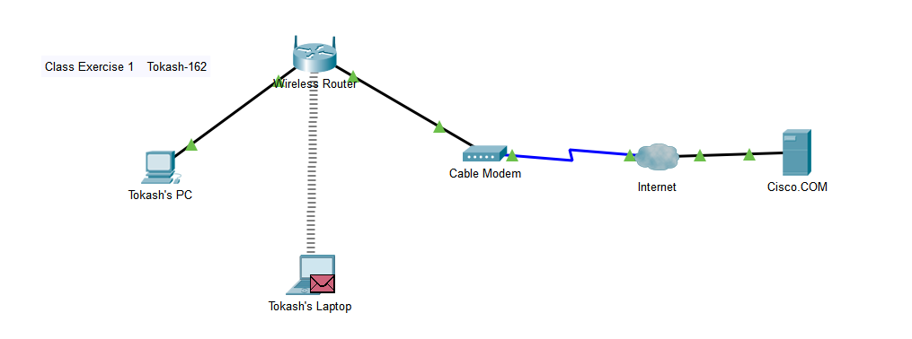

* To create your lab submission:
  1. Refer to the file LAB SUBMISSION FORMAT for formatting headers
  2. Name your file LAB01a-*lastname*.docx
  3. For this lab complete sections 1, 4 and 6.
  4. Copy your screenshot into section 4
* Submit in iLearn.
* Practice saving the file – make sure you know where it is saved to.

Note: Portions of this lab were modified from Cisco's Networking Academy